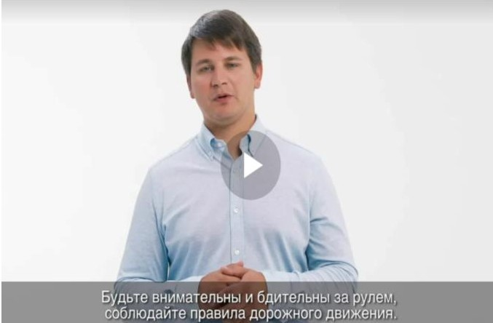

<https://yadi.sk/i/FG-5YJp_79oOdQ>

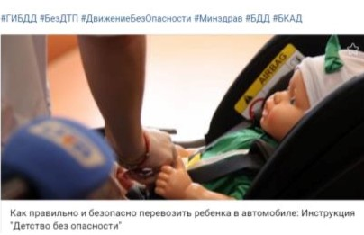

<https://www.youtube.com/watch?v=biXG1s9i2kE&feature=youtu.be>